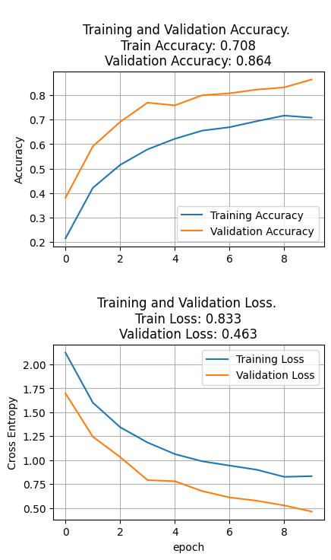

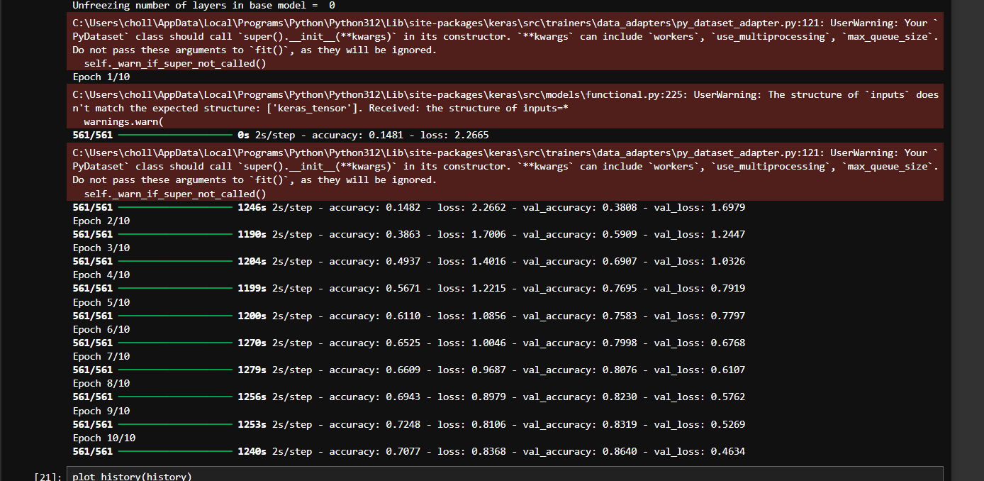

Precision (Micro): 0.8640

Recall (Micro): 0.8640

F1 Score (Micro): 0.8640

Class-wise Precision:

c0: 0.8297

c1: 0.9480

c2: 0.8314

c3: 0.8898

c4: 0.8605

c5: 0.8777

c6: 0.8659

c7: 0.8445

c8: 0.7820

c9: 0.9003

Class-wise Recall:

c0: 0.8207

c1: 0.8380

c2: 0.9042

c3: 0.8717

c4: 0.8605

c5: 0.9700

c6: 0.8621

c7: 0.9655

c8: 0.6897

c9: 0.8456

**Total params:** 14,789,258 (56.42 MB)

**Trainable params:** 14,789,258 (56.42 MB)

**Non-trainable params:** 0 (0.00 B)